**Bug Report**

**Website link: https://qa-test.solvative.dev/**

**BUG 1:**

**Issue Description**:

There is a discrepancy in the coffee prices displayed on the website. The prices listed on the home page differ from those shown in the menu section.

**High Priority and high severity**.

**Steps to Reproduce**:

1. Visit the website's home page.

2. Note the prices listed for each coffee type at home page:

- Dark coffee: $3.50

- Latte macchiato: $4.90

- Cafe latte: $3.75

- Cappuccino: $2.90

3. Navigate to the menu section of the website.

4. Compare the prices listed for each coffee type at menu section:

- Dark coffee: Missing

- Latte macchiato: $2.00

- Cafe latte: $2.50

- Cappuccino: $3.50

**Expected Behaviour**:

The prices for each coffee type should be consistent across all sections of the website, ensuring accuracy and coherence for users.

**Actual Behaviour**:

The prices listed on the home page do not match those displayed in the menu section. Additionally, the dark coffee option is missing from the menu section.

**Environment**:

Tested on Chrome and Edge browsers.

**Additional Information**:

This inconsistency may lead to confusion for users and could potentially impact their purchasing decisions. It is recommended to investigate and resolve this issue promptly to maintain the integrity and usability of the website.

**Screenshots:** Difference in price on menu and homepage.

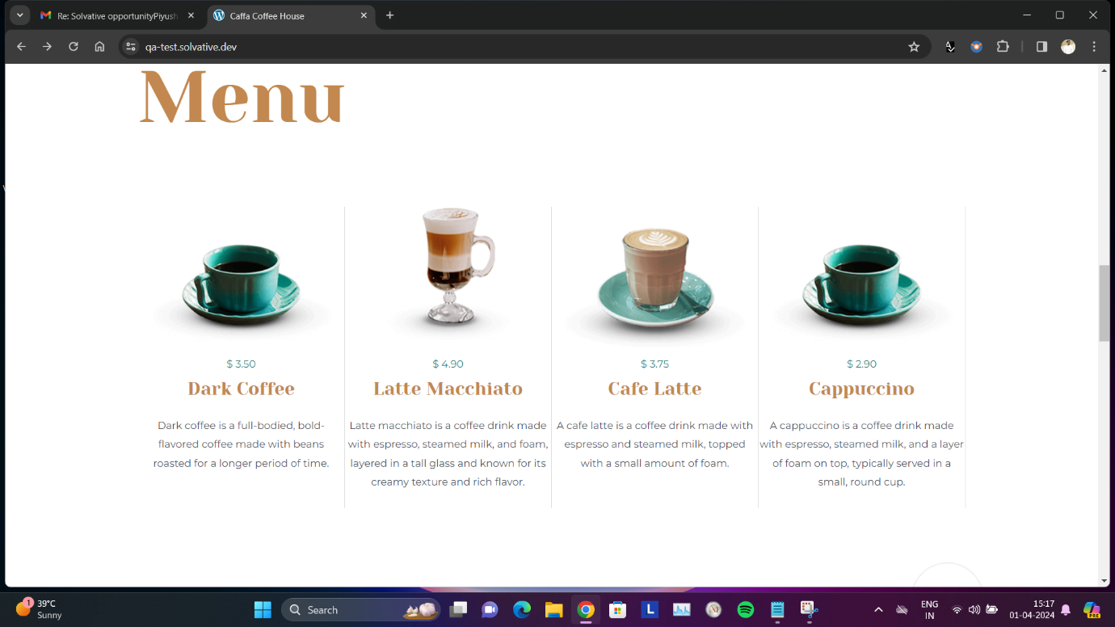

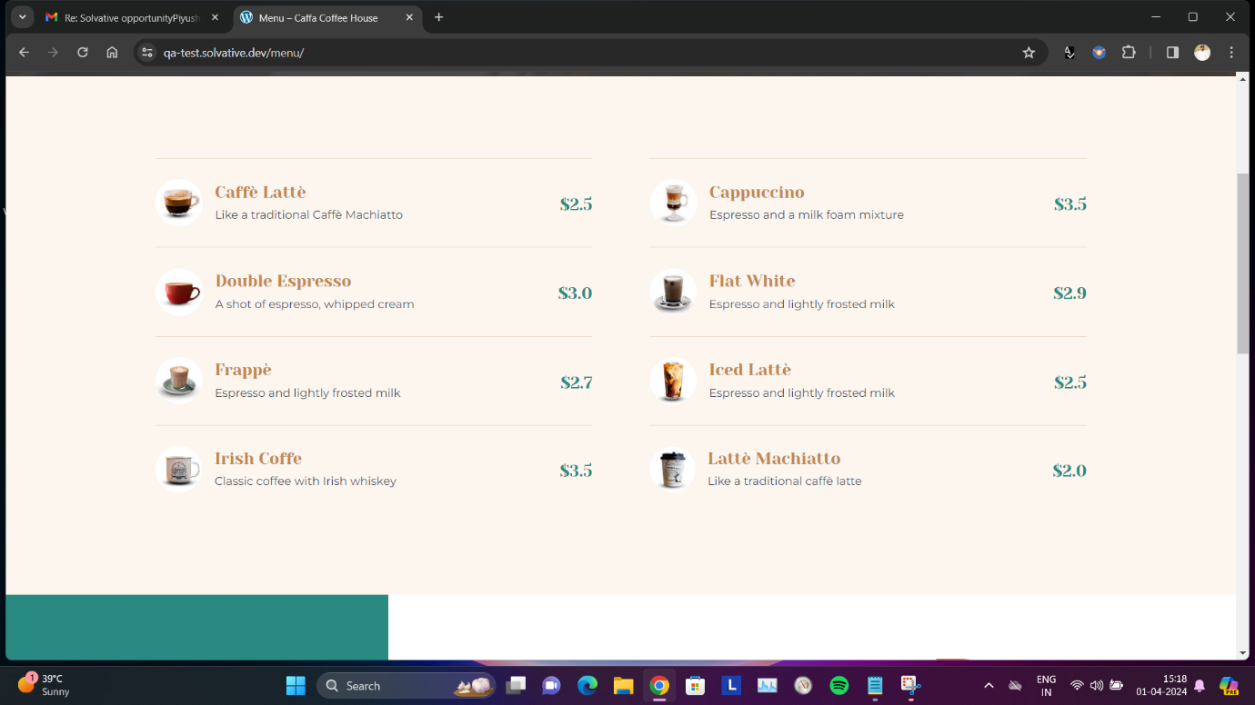

**BUG 2:**

**Issue Description**:

The social media icons on the website are consistently redirecting users to the incorrect social media platforms. Specifically, clicking on the Twitter icon directs users to the Instagram page, and clicking on the Instagram icon leads users to the Twitter page.

**Low severity and low priority.**

**Steps to Reproduce**:

1. Visit the website using either Chrome or Edge browser.

2. Locate the social media icons, specifically the Twitter and Instagram icons.

3. Click on the Twitter icon.

4. Observe that the Instagram page is opened instead of the expected Twitter page.

5. Click on the Instagram icon.

6. Notice that the Twitter page is opened instead of the expected Instagram page.

7. Repeat the above steps multiple times to confirm the consistency of the issue.

**Expected Behaviour**:

Clicking on the Twitter icon should navigate users to the Twitter page associated with the website, while clicking on the Instagram icon should lead users to the Instagram page linked to the website.

**Actual Behaviour**:

The social media icons consistently redirect users to the incorrect platforms, causing confusion and frustration for users attempting to engage with the website's social media accounts.

**Environment:**

The issue persists across multiple tests on both Chrome and Edge browsers.

**Additional Information:**

Repeated testing across different browsers confirms that the issue is not browser-specific. This suggests that the problem lies within the website's code or configuration rather than being a browser-related issue. Resolving this issue promptly will enhance user experience and ensure that users are directed to the correct social media platforms associated with the website.

**Screenshots: PICTURE 1-** When we select Instagram, twitter(X) opens.

**PICTURE 2-** When we select Twitter, Instagram opens.

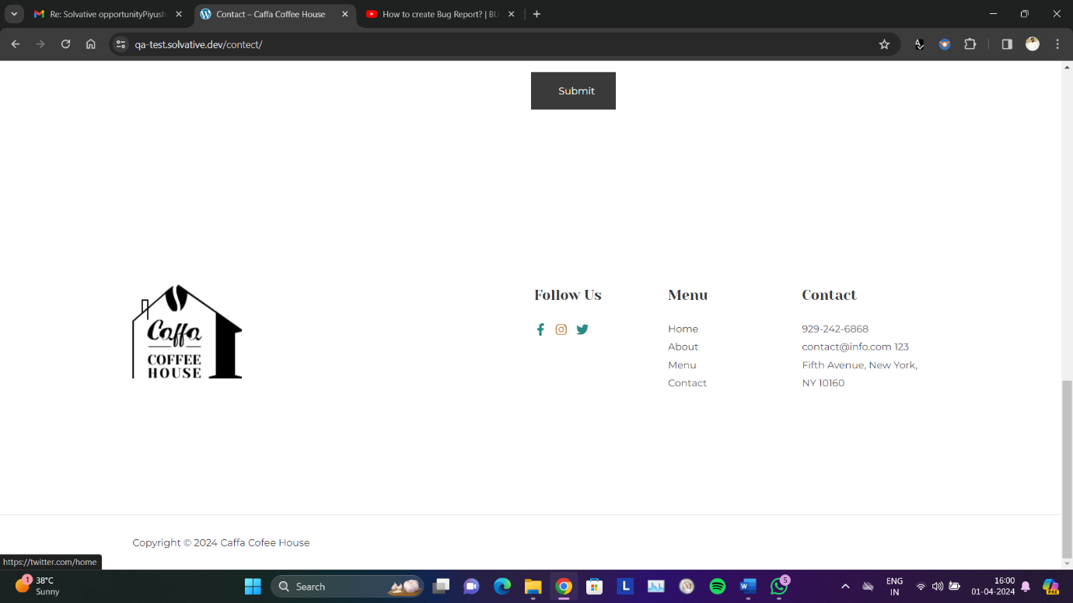

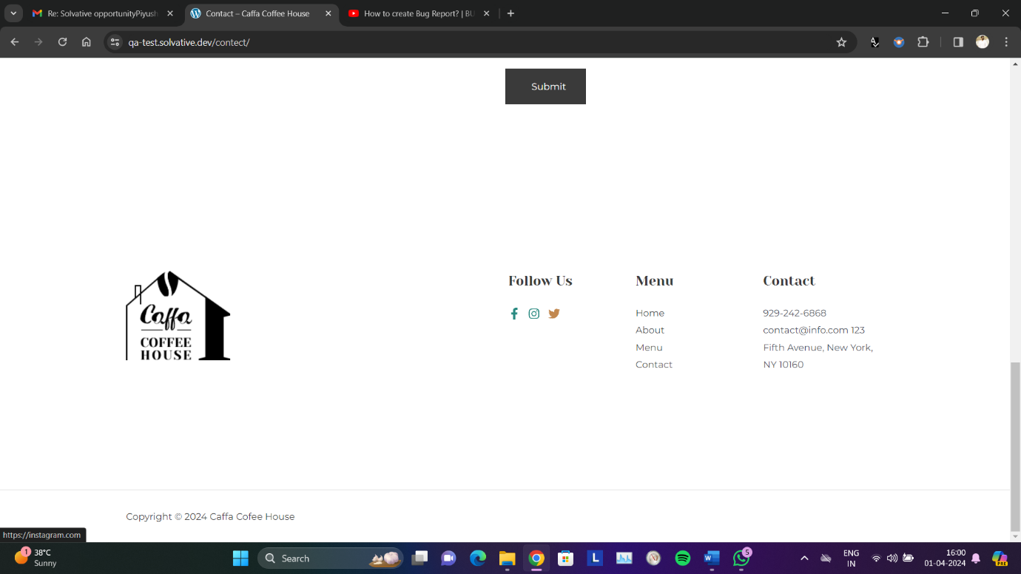

**Bug 3:**

Form Validation and Error Handling Issues.

**High Severity**: (Disrupts core functionality, poor user experience)

**Summary**: The website's form functionality exhibits incorrect field validation and ineffective error handling.

**Environment**:

Chrome, Edge

**Issues**:

1. Incorrect Name Validation: The name field accepts numbers and special characters.

Expected Behaviour: The name field should only accept alphabetic characters.

2. Invalid Email Validation: The email field accepts numbers and formats lacking "@email.com" structure.

Expected Behaviour: The email field should follow the standard email format ([email address removed]).

3. Incorrect Mobile Number Validation: The mobile number field should be restricted to 10 digits, but it currently allows more.

Expected Behaviour: The mobile number field should accept only 10-digit numbers.

4. Generic Error Message: The form displays a generic "Something went wrong, please try again" error after submission.

Expected Behaviour: Specific and informative error messages indicating the validation issue(s) should be displayed next to the relevant field(s).

**Steps to Reproduce:**

1. Open the affected web page in Chrome or Edge.

2. Attempt to enter numbers and special characters in the name field.

3. Attempt to enter numbers or an invalid format in the email field (e.g., "userexample" without the @ and domain).

4. Attempt to enter more than 10 digits in the mobile number field.

5. Click the submit button. Observe the generic error message.

**Recommendations**:

Name field allows only letters (A-Z, a-z).

Email field matches the standard email pattern.

Mobile number field accepts a fixed 10-digit format.

Provide clear error messages in line with the problematic fields.

**Screenshots:**

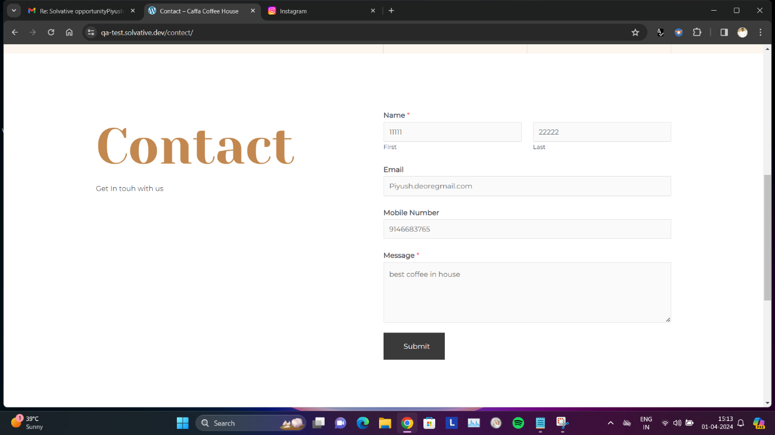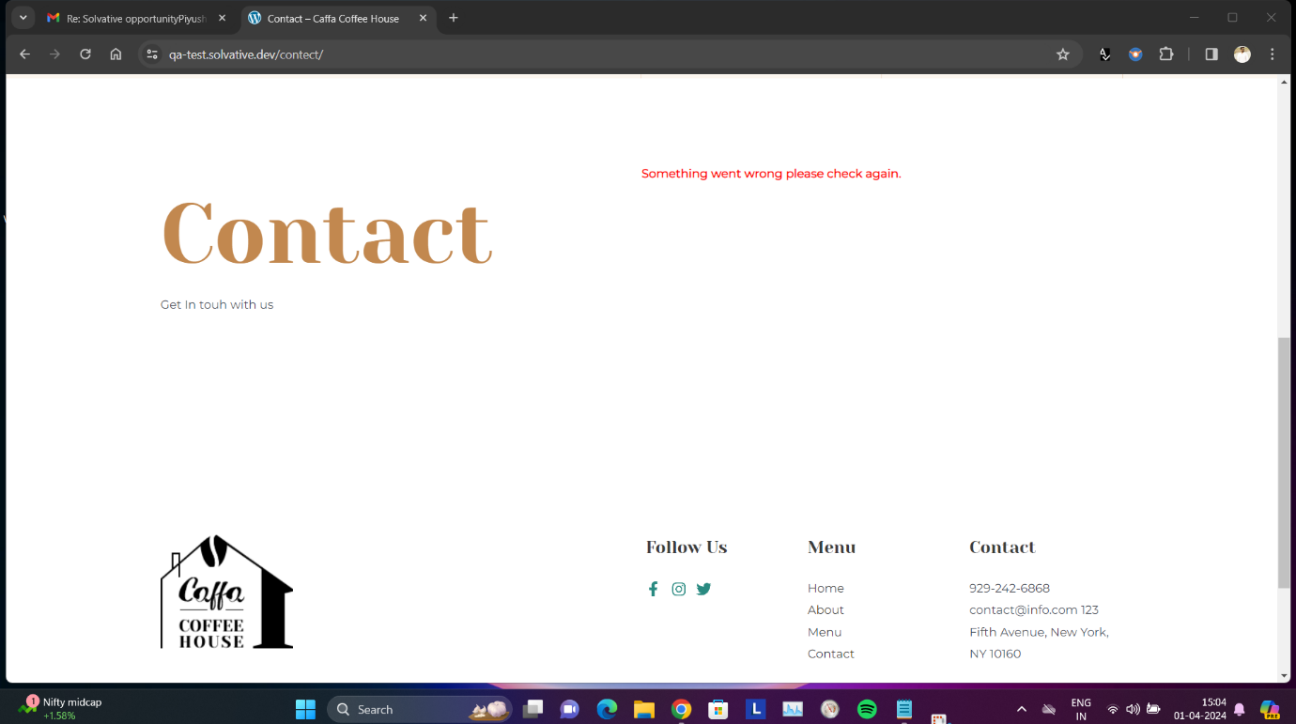

**Bug 4:**

**Issue Description:**

**Low severity and low priority.**

An inconsistency is observed in the behaviour of an arrow link that is intended to navigate users to the contact us page. When clicked, the arrow link redirects users to the home page instead of the contact us page. This issue occurs on both Chrome and Edge browsers. However, the same arrow link functions correctly, directing users to the contact us page in some instances.

**Steps to Reproduce:**

1. Visit the website using either Chrome or Edge browser.

2. Locate the arrow link intended to navigate to the contact us page.

3. Click on the arrow link.

4. Observe that, in some instances, the link redirects users to the home page instead of the contact us page.

5. Repeat the above steps to confirm the inconsistency in behaviour.

**Expected Behaviour:**

Clicking on the arrow link should consistently navigate users to the contact us page, ensuring smooth **and intuitive navigation throughout the website.**

**Actual Behaviour:**

Inconsistency is observed in the behaviour of the arrow link. While it correctly redirects users to the contact us page in some instances, it erroneously redirects users to the home page in others, leading to confusion and potential frustration.

**Environment:**

The issue is reproducible across multiple tests on both Chrome and Edge browsers, indicating that the inconsistency is not browser-specific but rather a systemic issue within the website's functionality.

**Screenshots:**